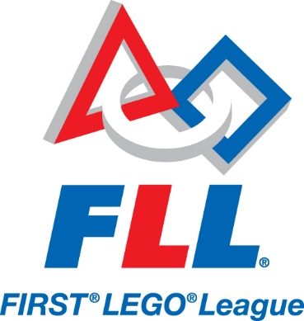

First lego league competition robotics
When students are engaged in hands-on STEM experiences, they build confidence, grow their knowledge and develop habits of learning. When adults coach these students, they encourage them to try, fail, and try again, while connecting STEM concepts to real-world examples.
FIRST® LEGO® League is the most accessible, guided, global robotics competition, helping students and teachers to build a better future together. The program is built around theme-based Challenges to engage children ages 9 to 16* in research, problem solving, coding, and engineering. The foundation of the program is the FIRST® Core Values, which emphasize teamwork, discovery, and innovation. Students emerge more confident, excited, and equipped with the skills they need in a changing workforce.

Open to Middle School (6-8) Graders

Tuesdays and Thursdays afterschool (3:15-4:00)

No fee upfront (may later need transportation fees to go to competition)

Contact Miss Caitlin Smith (room 120) at csmith@queencitystem.org or call 980-299-6633 ext. 120 to sign up and to get more information.

Ancient greek language
Learning Ancient Greek allows one to better understand the mechanics of grammar, gives access and nuance to a wide range of vocabulary in both common English and technical words, such as in the sciences, and allows one to be able to rapidly learn even more languages.
In conjunction with Latin, Greek is fun and will greatly expand your ability to read and write effectively. Language acquisition will help establish a well-rounded education along with the STEM education offered at QCSS. We will spend a large portion of time learning grammar, syntax, and vocabulary of the Ancient Greek language, while incorporating elements of history, art, literature, myth, and culture.

Open to 8th and 9th Graders only

Mondays afterschool (3:15-4:00)

No fee

Contact Miss Caitlin Smith (room 120) at csmith@queencitystem.org or call 980-299-6633 ext. 120 to sign up and to get more information.

